**Logical Database Design - Instructional Technology Services**

**UML Diagram**

Diagrams.net Link: <https://drive.google.com/file/d/1wt_LH8MZB4Hp6eK-Ugvxhx6VWJbdwV1e/view?usp=sharing>

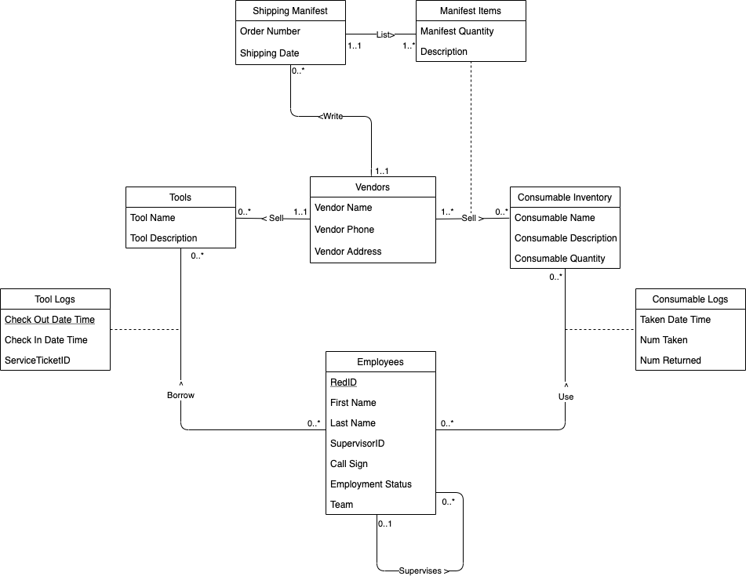

**Logical Database Design**

tblEmployees (RedID, FirstName, LastName, SupervisorID, CallSign, EmploymentStatus, Team)

fk SupervisorID references tblEmployees

tblTools (ToolID, ToolName, ToolDescription, VendorID)

fk VendorID references tblVendors

Not null VendorID

tblToolLogs (RedID, ToolID, CheckOutDateTime, CheckInDateTime, ServiceTicketID)

fk RedID references tblEmployees

fk ToolID references tblTools

tblConsumableInventory (ConsumableID, ConsumableName, ConsumableDescription, ConsumableQuantity)

tblConsumableLogs (RedID, ConsumableID,TakenDateTime, NumTaken, NumReturned)

fk RedID references tblEmployees

fk ConsumableID references tblConsumableInventory

Not null NumTaken

tblVendors (VendorID, VendorName, VendorPhone, VendorAddress)

tblShippingManifest (ManifestID, OrderNumber, ShippingDate, VendorID)

fk VendorID references Vendors

Not null VendorID

tblManifestItems (ConsumableID, VendorID, ItemDescription, ManifestQuantity, ManifestID)

fk ConsumableID references tblConsumableInventory

fk VendorID references tblVendors

fk ManifestID references tblShippingManifest

Not null ManifestID